Assignments for 6/1/20- 6/9/20

DEAR FAMILIES,

THIS IS OUR LAST WEEK OF WORK FOR THIS SCHOOL YEAR. TO ENSURE STUDENTS HAVE ENOUGH TIME TO COMPLETE ALL ASSIGNMENTS, THIS WEEK HAS A LIGHT WORK LOAD. HAND IN ALL ASSIGNMENTS BY JUNE 9, 2020 AS THAT IS THEIR LAST DAY. THANK YOU FOR ALL OF YOUR SUPPORT THIS YEAR.

HAPPY SUMMER,

MRS. PICCIRILLO, MISS AVERSA, MISS EVERTS, & MRS. JONES

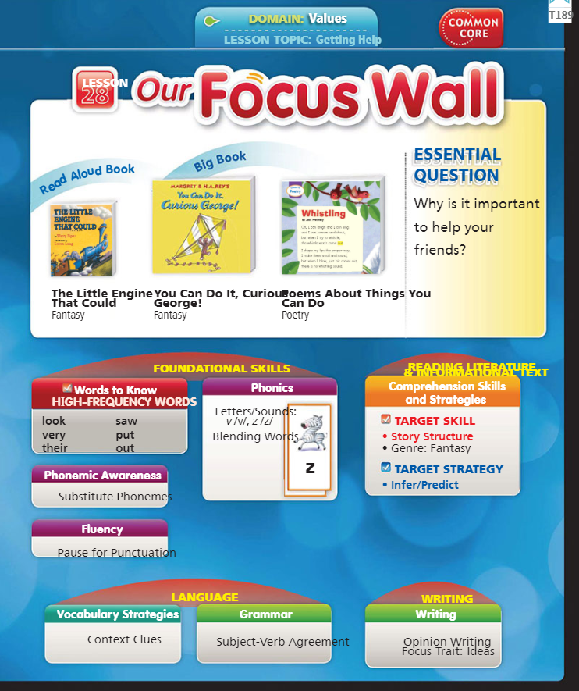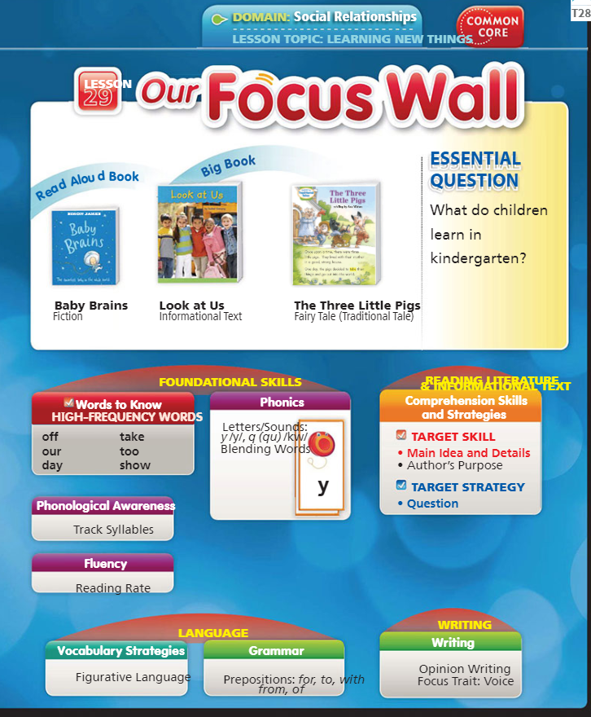

This weeks Topic: Getting Help and Learning New Things

Have students discuss how they ask for help when needed. Ask students how they feel when they learn something new? Do we sometimes need help when learning something new?
Our new sight words: look, very, their, saw, put, out, off, our, day, take, too, show

Read Aloud Book: The Little Engine That Could

Listen here: https://www.youtube.com/watch?v=xoKm5UzKK7k

Big Book: You Can Do It, Curious George

Listen here: https://www.youtube.com/watch?v=sa8pCvjAJIo

Read Aloud Book: Baby Brains

Listen here: https://www.youtube.com/watch?v=vOowC7e98pI

Big Book: Look at Us

Listen here: https://www.youtube.com/watch?v=YdNT2ie6AL0

ELA-

- Click on the links above to listen to our stories this week.

- Writing- Write about your favorite part of Kindergarten this year? Why was that your favorite part?

(EXAMPLE: My favorite part was _______. I liked it because ________. )

(EXAMPLE of a picture to match: draw a picture of a their favorite part)

- 5 minutes of fun ELA from our ELA page

Suggestions for Sight Words-

Practice writing words, use them in a sentence, do a word hunt in your favorite book, write them on flash cards!

Math-

Practice writing your numbers 1-100

- Count out loud to a family member from 1-100

FUNdations-

CVC-e Review-

https://www.youtube.com/watch?v=SUp-nnGusvk

Watch this Diagraph Video: https://www.youtube.com/watch?v=a4RN7iLx3cY

Do this Diagraph Sheet:

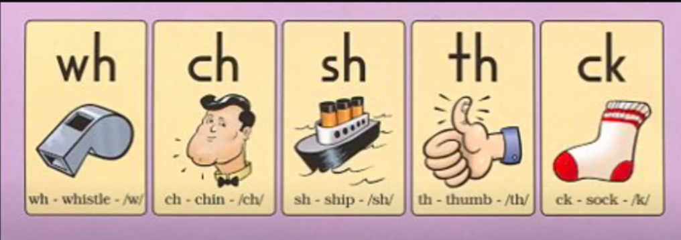

For Fun:

What I loved This Year Sheet

My Summer Bucket List Sheet

End of the Year Memory Book:

